
COMSATS Institute of Information Technology
Park Road, Chak Shahzad, Islamabad

Department of Computer Science

FYP Repository

Submitted By:

Adil Rasheed Khan
Sp12-Bcs-016

Ahmad Ehsan
Sp12-Bcs-027

Supervised By:

Dr. Munam Ali Shah

Co-Supervised By:

Muhammad Hassan Khan

Category of our project
Web Application and Mobile Application

Project Description

Problem Statement
Currently FYPs are being managed through Dropbox & Google site. FYP portal exists but students does not cover many use cases. There is no history of previous projects and no instantly evaluation of projects by FYP committee. Students are unable to check their remarks regarding their projects after their presentation. Students have difficulty to share their personal ideas on FYP portal where a member of PC can supervise them. FYP portal doesn’t interact PC to students where students get feedback regarding their queries. Students also have difficulty to see the announcement of any project allocation, scheduling and student have no information about seminars of FYP’s that are conducting for final year students.

Problem Solution
An existing FYP portal system is their but with limited functionality. A new FYP portal needs to be developed which will address the issues of existing system and will add the new features. It is need to shifting the whole process of FYP management on our local server with more features, flexibility and convenience. In this portal, student can check projects of previous years, share their ideas for FYP with PC and they can easily get notifications and updates about their FYP’s.

A web based and mobile application shall be developed where PC evaluates the students during their presentation and students can get their remarks from PC instantly after their presentation. Students can also get feedback after putting their queries in the portal. Students will also updated with a calendar that will notify the students to schedule their time.

Advantages/Benefits of proposed system
Student can obtain information from different milestones of their FYP’s but advantages of our proposed systems are as follows:
- Students can obtain necessary information of their FYP’s from the FYP portal. Such as scope template and other document templates etc.
- FYP Students will send messages/quires to PC members and their supervisors on this portal.
- Best feature of this portal is that PC will be able to evaluate the students during their presentation and student can see their remarks from PC.
- Previously developed FYPs can be explored on this portal.
- FYP students will be updated with new announcements.

Scope
The FYP portal shall have four main components, such as students, department (admin), supervisors, project committee.
Students will be registered by their department’s administrator and administrator will assign the password regarding students’ registration number (Reg. #). Students can view projects that are listed on the portal. Projects shall have a status (assigned or not-assigned).
The department (admin) will register the students and they can add notification to alert the students. Supervisor will supervise those students who are listed on the FYP portal. CU Online will not connect with this portal.
Instantly evaluate the students and instantly student can check their remarks. Project committee will evaluates the students during student’s presentation and student will get remarks after their submission and presentation on the portal.

Modules:
All the modules and features given below are from the perspective of FYP Portal.
- User Management
User can be a student, supervisor, co-supervisor and project committee member. User management will do as follow:
  - Add, Delete, View user.
  - Add, Delete, View proposed projects
- Project Management
- Upload projects
- Assign projects to students
- De-assign projects
- Track progress of projects currently develop
- Notification Management
  - Add notification related to projects.
  - Update notification.
  - Delete notification.
  - View all projects notification.
- Evaluation Management
- Add evaluation remarks
- Update remarks
- Delete remarks
- View remarks
- Schedule Management
- Create schedule.
- Update schedule.
- View schedule.

Constraints

The FYP portal will be useable for computer science department. The time constraint is that the project is being developed as a requirement of BS degree and it must be completed in one year.

Tools and Technologies
Visual studio, Eclipse, SQL Server will be used for implementation. APIs defines the proper way for a developer or user to request services from the program, and the languages are used to implement the program. There are following languages that will implement APIs and the both web based application and mobile application.
- JavaScript
- HTML
- XAML
- XML
- AJAX
- jQuery
- Asp.net (C#)
- Java

Roles and Project Stakeholders
Following are the roles and project stakeholders.

Project Sponsor | Dr. Munam Ali Shah
Stakeholder | Project Committee: Evaluation of the project, remarks on the project.  Students can see remarks.  .
Team Member | Adil Rasheed Khan, Ahmad Ehsan

Project Approach

Planned Approach
- Research on existing system (i.e. FYP portal).
- Take Interview to students with different questions who are currently using existing system.
- Search different and related applications to observe what can be new features for new system.
- Analyze that there is a need to add more features in existing system.

Work regarding planned approach
Problem understanding
Requirement analysis
Requirement validation
Documentation
Implementation
Designing
Coding
Testing

Incremental development
Incremental development is a software development model based on requirement analysis, specification, development and validation. In incremental development model each version adding functionality in previous version.

Project Estimates

Estimated Schedule
Key Project milestones relative to project start are as follows:

Project Milestones | Target Date
Project start | 01/03/2015
Problem Understanding | 07/03/2015
Requirement Gathering | 17/03/2015
Requirement Analysis | 24/03/2015
Requirement Document | 13/04/2015
Design Phase 1 | 27/04/2015
Design Phase 2 | 11/05/2015
Design Document | 16/05/2015
Revised Design Document | 22/05/2015
Implementing the Project | 06/11/2015
Testing Phase | 18/12/2016
Deployment | 29/12/2016
Project Completion | 30/12/2016

Resource Requirements – Team and Support Resources
The following personnel resources are required to complete this project:

Personnel Resource Types | Quantity
Superviser | 1
Co-superviser | 1
Project membre | 2
Host Domain | 1
Total Personnel Resources | 5

.

Mockups

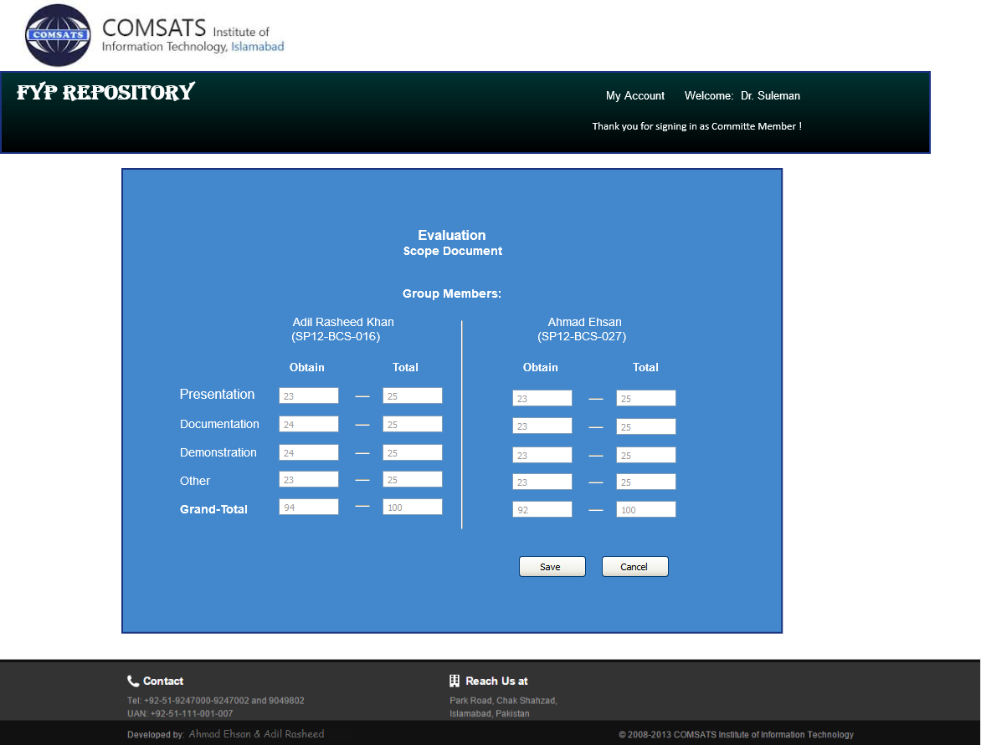

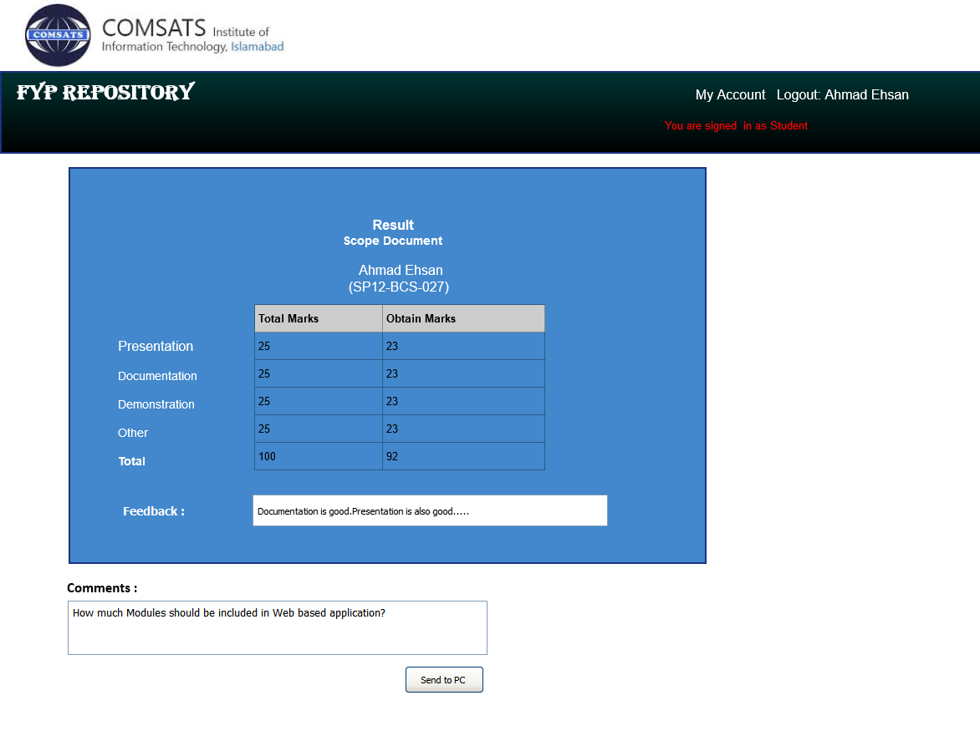

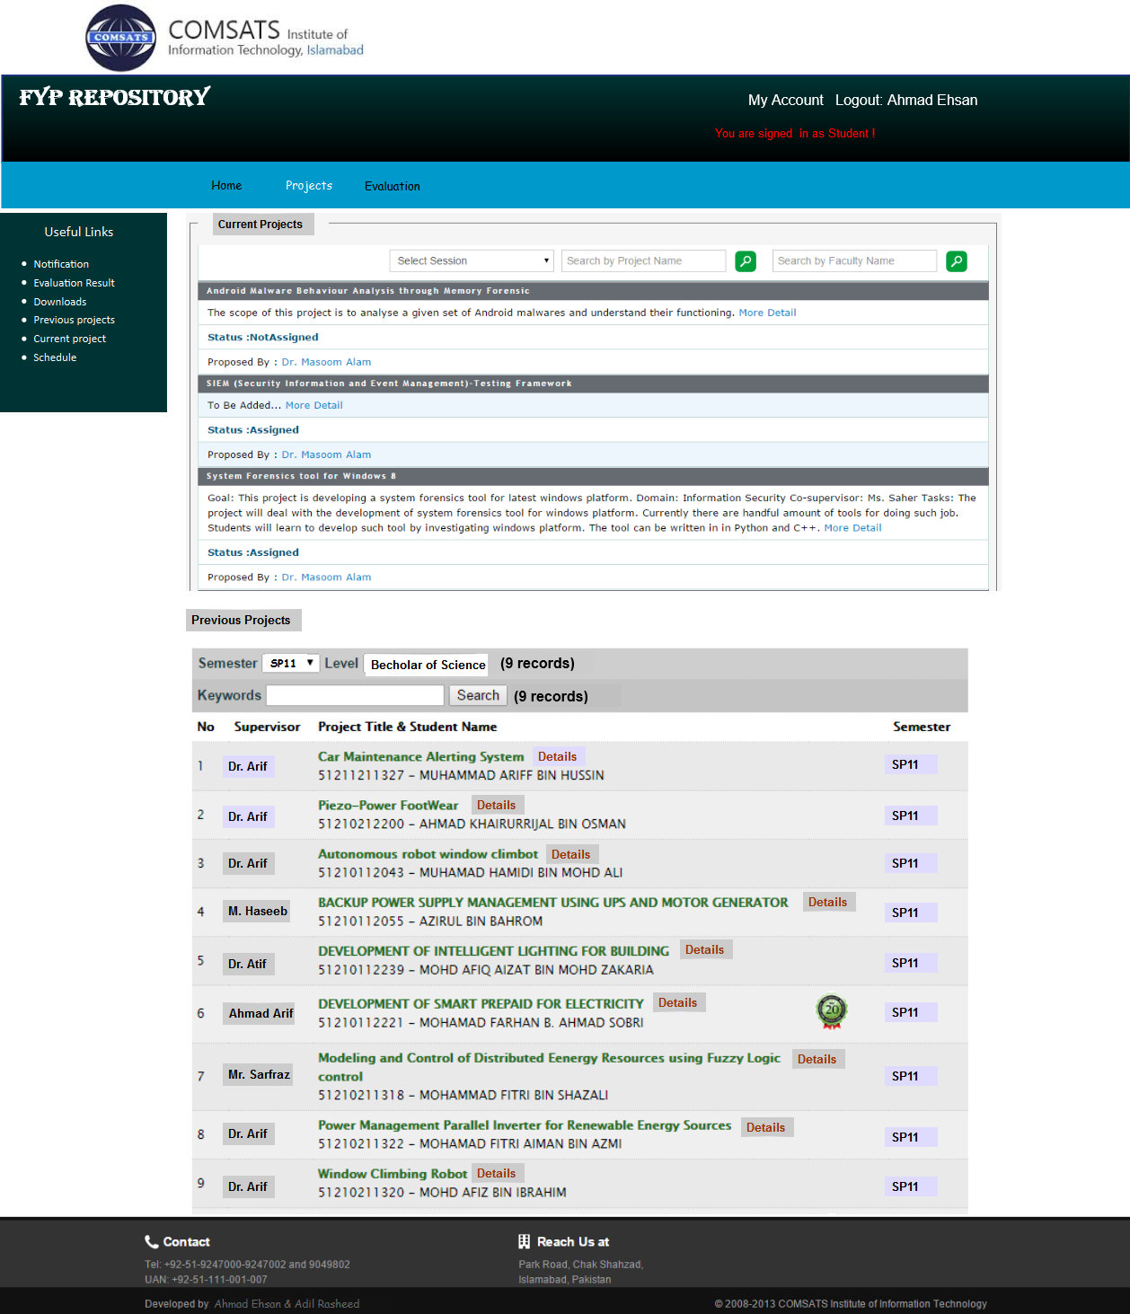

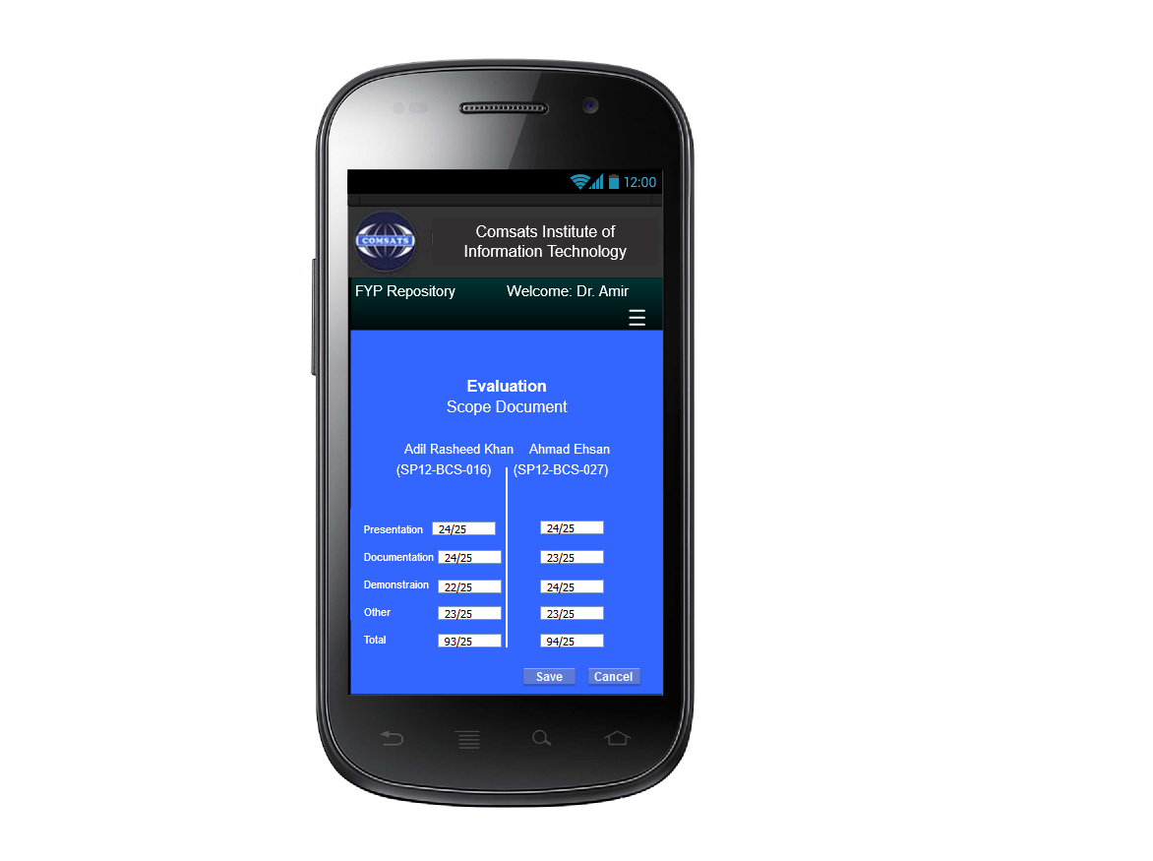

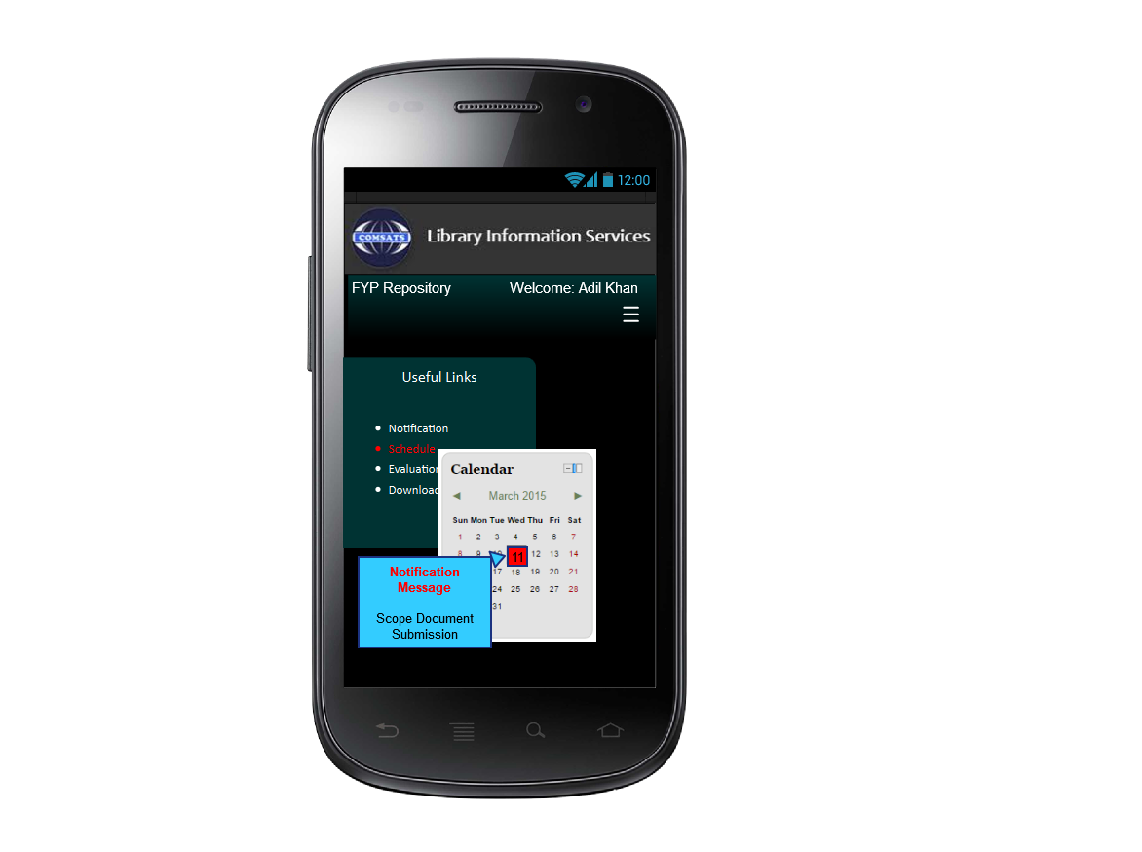

3.4 Gantt Chart

